

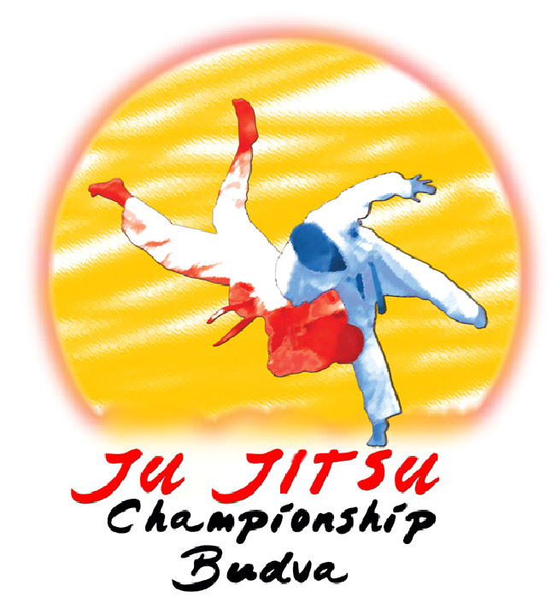
JU-JITSU FEDERATION OF MONTENEGRO

XI. INTERNATIONAL JU-JITSU TOURNAMENT

18th of MAY 2019

‘’B U D V A - OPEN 2019’’

XI. INTERNATIONAL JU-JITSU TOURNAMENT
GORLS, BOYS, ASPIRANTS, YUNIORS AND SENIORS
FIGHTING – DUO CLASIC SYSTEMS – DUO SHOW SISTEMS – NE WAZA

‘’ BUDVA - OPEN 2019’’ MONTENEGRO 18th MAY 2019.

SPORT CENTER “REA” BUDVA

PARTICIPATING CATEGORIES

FIGHTING

Seniors (+U21) and Male - 56 -62 -69 -77 -85 -94 +94
Juniors (U21) Female -45 -48 -52 -57 -63 -70 +70

Aspirants (U18) Male -46 -50 -55 -60 -66 -73 -81 +81
Female -40 -44 -48 -52 -57 -63 -70 +70

Cadets (U16) Male -38 -42 -46 -50 -55 -60 -66 -73 +73
Female -32 -36 -40 -44 -48 -52 -57 -63 +63

Children (U14) Male -30 -34 -38 -42 -46 -50 -55 -60 -66 +66
Female -25 -28 -32 -36 -40 -44 -48 -52 -57 +57

Children (U12) Male -24 -27 -30 -34 -38 -42 -46 -50 +50
Female -22 -25 -28 -32 -36 -40 -44 -48 +48

Children (U10) Male -21 -24 -27 -30 -34 -38 -42 +42
Female -20 -22 -25 -28 -32 -36 -40 +40

Children (U8) Male -14 -16 -18 -20 -24 -26 -30 -32 -34 +34
Female -14 -16 -18 -20 -24 -26 -30 -32 -34 +34

The organizer keeps the right to join weight categories in case of too small number fo competitors in each category.

NE WAZA

Seniors (U +21)and Male - 56 -62 -69 -77 -85 -94 +94
Juniors (U21) Female -45 -48 -52 -57 -63 -70 +70

Aspirants (U18) Male -46 -50 -55 -60 -66 -73 -81 +81
Female -40 -44 -48 -52 -57 -63 -70 +70

Cadets (U16) Male -38 -42 -46 -50 -55 -60 -66 -73 +73
Female -32 -36 -40 -44 -48 -52 -57 -63 +63

Children (U14) Male -30 -34 -38 -42 -46 -50 -55 -60 -66 +66
Female -25 -28 -32 -36 -40 -44 -48 -52 -57 +57

The organizer keeps the right to join weight categories in case of too small number fo competitors in each category.

DUO SYISTEM – DUO SHOW SISTEM

Seniors (U+21) and 1998 older Male Female Mix

Juniors (U21) 1999 2001 Male Female Mix

Aspirants (U18) 2002 2003 Male Female Mix

Cadets (U16) 2004 2005 Male Female Mix

Children (U14) 2006 2007 Male Female Mix

Children (U12) 2008 2009 Male Female Mix

Children (U10) 2010 2011 Male Female Mix

Children (U8) 2012 2013 Male Female Mix

The organizer keeps the right to join weight categories in case of too small number fo competitors in each category.

COMPETITION RULES
Fighting: ChildrenU8, U10, u12, U14, Cadets U16, Aspirants U18, Juniors U21 and Seniors U+21: JJIF Rules – for Children
U14 and Cadets U16 previous U15 rules apply
Children (U12): all three parts, no punches to the head, without locks and strangulations, full
ippon possible, the Osae-Komi 10 seconds for ippon, 6-9 seconds for waza-ari, fight duration 2
minutes
Children (U10): oll three parts, no punches to the head, without locks and strangulations, full
ippon possible, the Osae-Komi 10 seconds for ippon, 6-9 seconds for waza-ari, fight duration
1,5 minute
Children (U8): oll three parts, no punches to the head, without locks and strangulations, full
ippon possible, the Osae-Komi 10 seconds for ippon, 6-9 seconds for waza-ari, fight duration
1 minute

Ne-waza: U14, U16, U18, U21 and U+21: JJIF

Duo-system: U18, U21 and U+21: JJIF Rules (all series by draw)
Children (U14/U16): three (3) attacks from series A and B (drawn by the referee!)
Children (U12): three (3) attacks from series A and B ( free choice of attacks)
Children (U10): two (2) attacks trom series A and B (free choice of attacks)
Children (U8): three (3) attacks from series A (free choice of attacks)
Duo show In accordance with the JJIF rules.
JU JITSU OPEN BUDVA 2019
1. PROGRAM DATE | TIME | ACTIVITY | PLACE
Saturday 18 May 2019 | 07.30 - 08.30 h  08.00 - 09.00 h  09.30 h  12:00 h  12.30 h  14.00 - 14.30 h  14.30 h | - the team reports, checking payments and Measurement  - the meeting of referees and coaches - Hall of Sport SC”Rea” - Budva  - Beginning of competition  - Opening ceremony  - Continuing of competition  - Coffee Break  - Continuing of competition | Hall of Sport SC”Rea” - Budva

AWARDS
- The first three competitors in each category will receive medals (two third places),
- The first three best placed teams in the overall standings of the medals will receive trophies,
- Awards will be given to the best male and best female competitor in fighting system and to the most attractive couple in duo system.
RESPONSIBILITY:
- The organizer is not responsible for any damage to persons or their property before, during and after the competition! Management of clubs and the clubs themselves take responsibility for health of their competitors, with required possession of a medical certificate (which must not be older than 6 months) and possession of an insurance policy.
COMPETITION FEE
- Aspirants, Juniors and Seniors - fighting 15,00 €, duo system 30,00 €,
- Boys - fighting 10,00 €, duo system 20,00 €.

REFEREES:
-The number of referees is unlimited and if is possible to be the international. If applies more referees of required number, organizer and president of the Referee Commission of JJFMNE will primary determine those referees with international licenses and then with national licenses from each participating team.

Obbligatory EQUIPMENT:
1. Gloves for Ju-Jitsu fights - standard - soft, red and blue;
2. Protectors for the leg and foot, soft, red and blue, thickness 1 - 2 cm;
3. It is allowed to wear a mouthpiece and shield-jockstrap;
4. For girls - chest protector – soft as possible - under a white t-shirt;
5. Red and blue belt.
6. The organizer shall not be liable for personal injury, loss or damage to personal belonging sof competitors and
other property of the club, participating in or traveling to the tournament.

AWARD MEDAL
- Medals for the first three places will be delivered after finishing of each category.
- Pronounce of the best teams in the standings will proceed after the contest.
OTHER NOTES
- In case of insufficient number of competitors in aspirant, junior and senior categories (male or female), competition organizer reserves the right to merge certain categories together - fighting duo or the system. Any decision on this will be taken at a meeting of coaches and judges before the start of the competition.
- If you want us to provide you the hotel accommodation you are required to submit a list of participants until
05.05.2019.
- Available for participants are the Airports at Tivat – 20 km away from Budva and at Podgorica – 60 km away from Budva, or the Railway station at Bar – 30 km away from Budva.
- Discount of 10 % is provided on total competition fee for each team that brings over 30 competitors.

Accommodation - Just close to the sports hall we have arranged accommodation for the competitors and the representers of the clubs - for the price of 25€. In the price are included: breakfast and dinner. Please, to everyone who is interested in this accomodation, let us know by the 30.04.2019. so we could make reservations on time.
Because of the Sports games of small countries that are being hold partly in Budva, number of rooms are limited, so please let us know, so we could make reservations in the shortest period.

APPLICATIONS SHOULD BE SENT TO:
Ranko Vukotic - e-mail: ranko.vukotic@gmail.com ;
JJSCG - e-mail: jujutsu.mne@gmail.com
EVENT ORGANIZER

XI. INTERNATIONAL JU-JITSU TOURNAMENT
‘’ BUDVA - OPEN 2019’’ MONTENEGRO 18th MAY 2019.

Country

Team details
Name
Contact Person
Address
Phone number
E-mail address

Officials | Nº | Surname and name | title
 | 1.
 | 2.
 | 3.
 | 4.

Referee(s) | Nº | Surname and name | rank
 | 1.
 | 2.
 | NOTE:

DUO SISTEM
Br. | Competitors  Surname and name | Date of birth | Men/Women/Mix | Duo classik  Duo show | Category  U21, U18, U16, U14, U12, U10, U8
1.
2
1
2.
1
2.
1
2.
1
2.
1
2.
1
2.
1
2.
1
2.
1
2.
1
2.
1
2.
1
2.
1
2.

F I G H T I N G S Y S T E M
Br. | Competitors  Surname and name | Date of birth | Men/Woen | Kg | Category  U21, U18, U16, U14, U12, U10, U8
1.
2.
3.
4.
5.
6.
7.
8.
9.
10.
11
12.
13.
14.
15.

NE WAZA S Y S T E M
Br. | Competitors  Surname and name | Date of birth | Men/Woen | Kg | Category  U21, U18, U16, U14
1.
2.
3.
4.
5.
6.
7.
8.
9.
10.
11
12
13
14
15.

Greetings and Welcome to Budva!
EVENT ORGANIZER

